You get the next tables:
Locations
LocationID
LocationName
Address
City
Country
ContactPerson
Capacity
Cost

Events
EventID
LocationID
EventName
EventDate
EventCost

Create Table Locations(
LocationID number not null,
LocationName varchar2(100) not null,
Address varchar2(100) not null,
City varchar2(100) not null,
Country varchar2(100),
ContactPerson varchar2(100) not null,
Capacity number not null,
Cost number not null,
PRIMARY KEY(LocationID)
);

Create Table Events(
EventID number not null,
LocationID number not null,
EventName varchar2(100) not null,
EventDate date,
EventCost number not null,
PRIMARY KEY(EventID)
);

Insert Into Locations Values (1, 'Parcul central', 'str. baritiu nr 84', 'Cluj-Napoca', 'Romania','Ana Popescu',10000,0);
Insert Into Locations Values (2, 'Casa de Cultura', 'piata unirii', 'Cluj-Napoca', 'Romania','Dan Cristian',300,1000);
Insert Into Locations Values (3, 'Piata Revolutiei', 'str. baritiu nr 84', 'Bucuresti', 'Romania','Cristina Manole',10000,1000);
Insert Into Locations Values (4, 'Hugo Restaurant', 'str. 21 decembrie 1989', 'Cluj-Napoca', 'Romania','Crina Suciu',200,500);
Insert Into Locations Values (5, 'Piata Sfatului', 'str. statului nr 100', 'Brasov', 'Romania','Liana Marinescu',600,600);

Insert Into Events Values (1, 1, 'Zilele Orasului Cluj', DATE '2017-05-05', 10000);
Insert Into Events Values (2, 1, 'Zilele Tineretului', DATE '2017-06-06', 1000);
Insert Into Events Values (3, 1, 'Marea Hamaceala', DATE '2017-07-07', 400);
Insert Into Events Values (4, 1, 'Zilele Folk', DATE '2017-05-09', 2000);
Insert Into Events Values (5, 2, 'Concert Andra', DATE '2017-07-05', 5000);
Insert Into Events Values (6, 2, 'Concert colinde', DATE '2017-12-06', 1500);
Insert Into Events Values (7, 3, 'Concert Revelion', DATE '2017-12-31', 20000);
Insert Into Events Values (8, 4, 'Eveniment testare', DATE '2017-05-07', 2000);
Insert Into Events Values (9, 4, 'Eveniment lansare revista', DATE '2017-09-07', 1000);
Insert Into Events Values (10, 5, 'Cerbul de aur', DATE '2017-09-07', 5000);

- Perform the following queries on "Locations" table:

- select all locations that have the capacity between 200 and 1000 persons

select locationname
from locations
where capacity between 200 and 1000
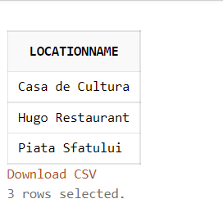

- select all locations that have "a" in their name

select locationname
from locations
where upper(locationname) like '%A%'
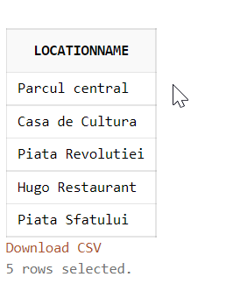
- Select all locations that are not in Cluj-Napoca
select locationname
from locations
where city<>'Cluj-Napoca'
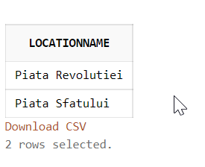

- Select all locations that have the cost 0,500,600, are in Brasov and Cluj-Napoca, and han sustain a capacity greater that 1000 persons

select locationname
from locations
where cost in (0,500,600) and city in ('Brasov','Cluj-Napoca') and capacity>1000
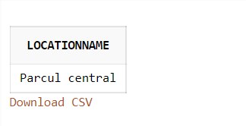

- Perform the following queries on "Events" table:

- return the results for min, max, average based on "EventCost" column

select Min(eventcost), max(eventcost), avg(eventcost)
from events
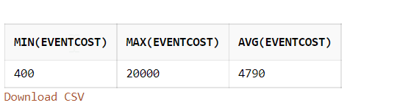

- count how many events are associated to location 1 and 2

select count(*)
from events
where locationid in (1,2);
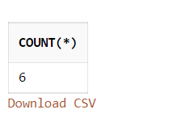

- compute the average cost obtained from location 1

select avg(eventcost)
from events
where locationid=1
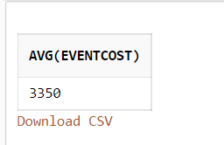

- order the events based on their defined date

select*
from events
order by eventdate
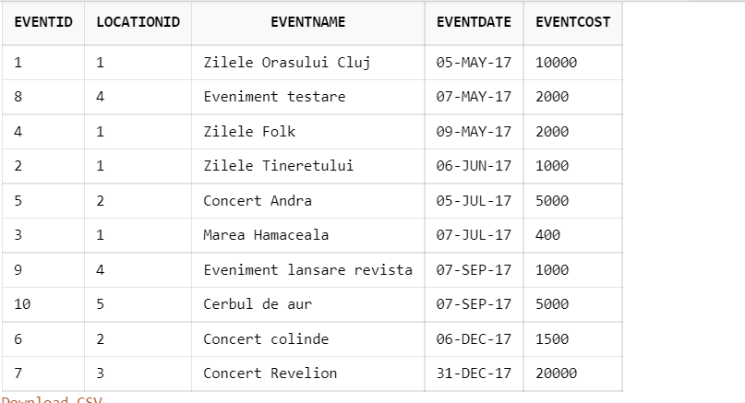

- compute the total cost associated with each location (hint grouped by)

select locationid, sum(eventcost) as total_cost
from events
group by locationid order by locationid
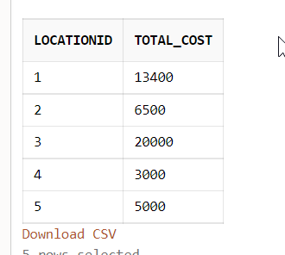

3. Perform the following queries using both tables

- Order location name, descending, after their associated event cost

select locations.locationname, events.eventcost
from locations
join events on locations.locationid=events.locationid
order by locationname desc, eventcost asc
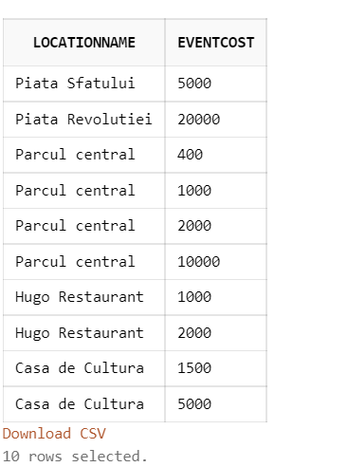

- Select location name, location cost and event cost for a specific event

select events.eventname, locations.locationname, locations.cost as locationcost, events.eventcost
from locations
join events on locations.locationid=events.locationid
order by events.eventid
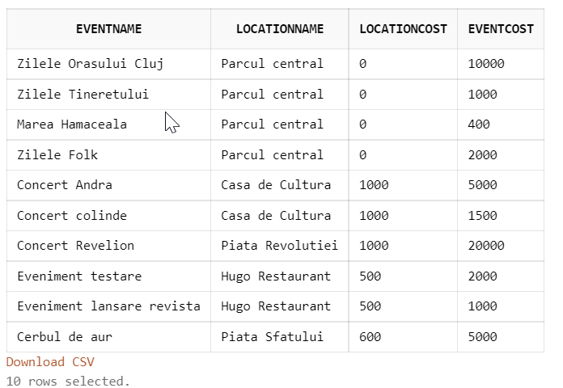
- Return the first 3 events (with eventName, locationname), that have the greatest event cost, in alphabetical order (after their names)
Select *
from ( select events.eventname, locations.locationname
from locations
join events on locations.locationid=events.locationid
order by eventcost desc, eventname fetch first 3 rows only)
order by eventname asc

